Hawaiian Cheesecake Salad
Prep time/Total time 15 min
16 Servings
Ingredients
8 oz cream cheese
3.4 oz package instant cheesecake pudding
1 cup French vanilla coffee creamer
1 lb strawberries
4 mandarin oranges
20 oz can pineapple tidbits
3 kiwis
2 mangoes
1 banana
Juice of ½ lemon
Directions
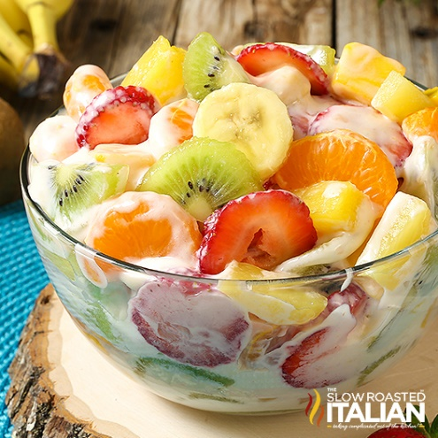
- Hull the strawberries and cut into slices. Peel and section the oranges. Peel and cut the kiwi into half moons. Cut mangoes into bite size pieces. Drain the pineapple tidbits. Set fruit aside.
- Microwave cream cheese for 20 seconds to soften.
- In a medium tall bowl, using an electric mixer, whip cream cheese until it becomes smooth. It may bind up in the beaters but continue as is and it will loosen up.
- Add the dry pudding mix. Beat about 2 minutes until well combined. If the mixture is too thick you can add a splash of the measured creamer to loosen it up.
- With the mixer running slowly, add creamer to the cream cheese approximately a tablespoon at a time (otherwise it will become lumpy). Mix until it becomes a smooth mixture and all the creamer has combined into the cream cheese. Continue to whip until smooth, light and fluffy, about 2 minutes.
- Add strawberries, oranges, pineapple, kiwi and mango to the cheesecake mixture.
- Cut the banana into coins and place in a small bowl. Toss with lemon juice until well coated. Drain the excess juice.
- Gently fold the banana into the cheesecake salad.
- Serve immediately or chill until ready to serve.
Notes
To make ahead of time, prepare cheesecake mixture and refrigerate in a bowl. Mix all the fruit in a large bowl and refrigerate. Before serving, drain any excess liquid from the fruit and then fold the cheesecake filling into the fruit.
You can substitute 1 cup heavy cream, ¼ cup powdered sugar and 2 teaspoons of vanilla extract for creamer.

